Abstract

1. EDB 2.0

How Eagle Europeana project improved the Epigraphic Database Bari

Anita Rocco

Dip. di Scienze dell'Antichità e del Tardo Antico, Università degli Studi di Bari "Aldo Moro"

Email: anita.rocco@uniba.it

This paper is dedicated to the evolution of the Epigraphic Database Bari (EDB) from the minimalistic design of its origins to the current status. Although EDB, the database of inscriptions by Christians from Rome, dates back to the late-80s of the last century, the involvement in the EAGLE – Europeana project has had a significantly positive impact on its development.

In fact, maintaining its peculiar character, dictated by its own story and, mostly, by the characteristics of its documentary base, it has taken advantage of the solutions adopted to integrate different archives and of the best practices purpose-built.

**Keywords**

Epigraphic database, EDB, EAGLE Europeana, Christian inscriptions, Late antique inscriptions

1. Introduction

The Epigraphic Database Bari (EDB) is an 'old' database, its story dates back to the late-80s of the last century, when Carlo Carletti[1], inspired by Jory's experience on indexing CIL VI[2], started a project of digitization of the inscriptions commissioned by Christians from Rome between IIIrd and VIIIth century, collected and edited in the 27.688 lemmas of the ICVR[3]. The data were stored in a data processing program, called ICVR, running under MS-DOS, later converted in a database for Microsoft Access. It was originally intended for internal use only.

Since its very beginnings the database has been designed on the basis of a conceptual model, which conveys the complexity of epigraphs even in the frame of a very simple and basic IT structure.

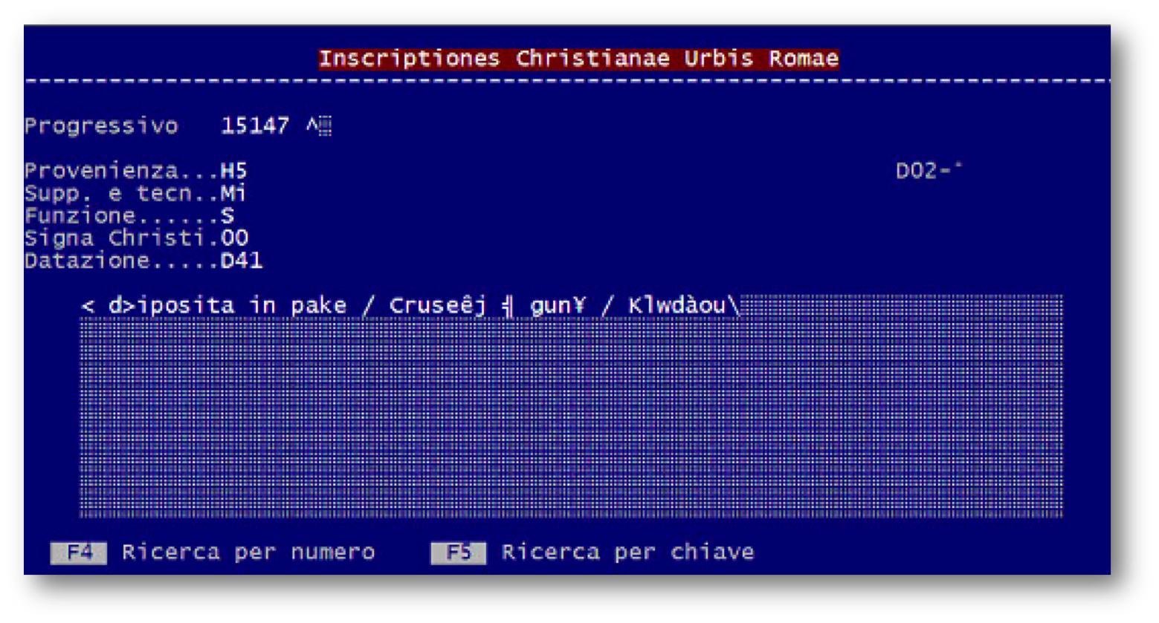

Fig. 1. The record of a bilingual inscription (ICVR V, 15147) as it appeared in data processing program ICVR in MS-DOS in 1988.

The data processing program recorded for each inscription in addition to the text[4]: bibliographic data (Progressivo = ICVR Number), context of original pertaining (Provenienza), type of support and executing technique (Supp. e tecn.), function (Funzione), if there are Christograms (*Signa Christi*), dating (Datazione). All those information were expressed by alphanumeric codes of few charachters, according to limitation imposed by the program (Fig. 1).

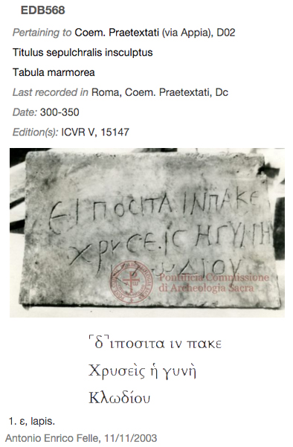

Fig. 2. The inscription ICVR V, 15147 as it appear now in EDB, with the acronyms expanded, the image and the text displayed in Greek characters.

Adding *metadata* to the text, even if in the minimalistic form of alphanumeric codes, accomplished the goal of describing the epigraphic object in its widest sense of inscribed artifact. This feature, in particular relating to geographical information, was even more meaningful according to the characteristics of a large part of the inscriptions recorded in EDB. In fact, the original pertinence to a monument/container (catacomb) or to a particular area of it, allows, with reasonable certainty, to determine the patronage by a member of the Christian community and moreover to determine the chronology, even unless specific references inside the text[5]. Likewise reporting the presence of Christological monograms allows emphasizing them as explicit symbols of Christian faith and as chronological indicators [6].

In the early 2000s, the ICVR database, containing more than 20,000 records, became part of the federation of databases Eagle (Electronic Archive of Greek and Latin Epigraphy), under the patronage of the International Association of épigraphie Grecque et Latine (AIEGL) as EDB (Epigraphic Database Bari) and extended its competences to the epigraphic documentation of Christian patronage of the city of Rome, published after the volumes of ICVR.



Fig. 2. The EDB homepage in 2004 and 2009.

As a member of the federation, the database became available online through its own dedicated website and finally, thanks to the EAGLE Europeana project, through a common portal.

Obviously this step has resulted in a series of changes and adjustments that led from the original basic structure of the database to the present one.

2. The EDB structure

The current structure of EDB consists of a relational database, based on the program open-source My-SQL, with a complex scheme drafted according to the most recent acquisitions of the epigraphic methodology: reestablishing historical and material value of the object, identifying each epigraph as a complex and polysemic product, consisted of text, but not only of it.

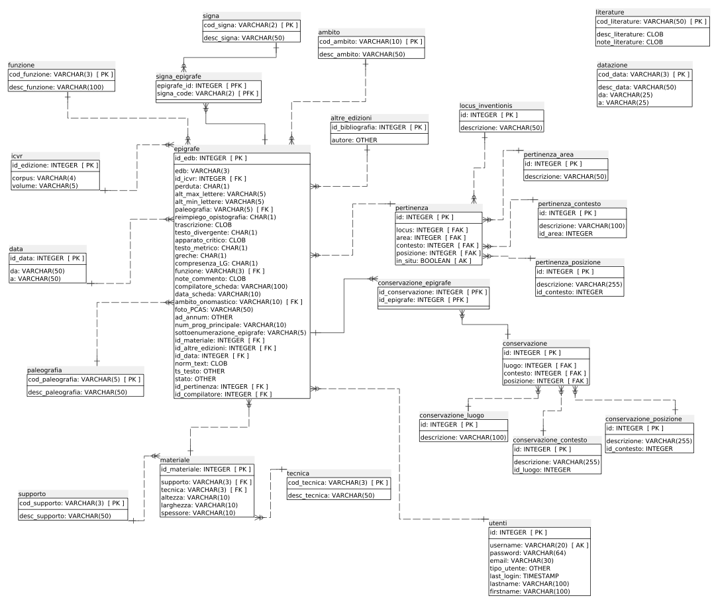

Fig. 3. The EDB database schema.

**2.1 Bibliographic data**

As in the past version, the first information recorded for each epigraphic document are bibliographic data.

Besides data related to the ICVR publication - volume and edition number of the inscription - now EDB is able to record other bibliographic references as well as concordances with other *Corpora* (CIL, IG, IGUR, IGC).

The whole bibliography is structured in metadata and is available both on EDB website, and on the EAGLE BPN group of Zotero[7], a tool for managing bibliographic data, that makes it easy to export and to cite them. An additional field allows to record references and links to other online databases.

It's even possible to define the relationship between the epigraph and the cited bibliography (printed or digital): *identity*, when it is an edition; *integration*, if it's the edition of another fragment of the same inscription; *opistographic*, if it's the edition of the inscription on the back side; *reuse*, if it's the edition of another inscription on the same support; *comment*, if it's a study on a related topic.

**2.2 Geographic data**

One key element of differentiation of EDB from other similar projects is the structuring of the topographic data.

This is due to the fact that the inscriptions of interest of EDB pertain only to the city of Rome, an area far more limited compared to the large geographic ones managed by other epigraphic databases, but also and above all to the fact that, as has been said previously, a large number of inscriptions of the Christians of Rome is still preserved in the place for which it was created, sealing a tomb of an underground cemetery. Morever, even if it isn't still in its place on the grave, however, it is,often attributable to a specific area of the funerary complex.

Consequently in EDB, geographic indications require a more detailed articulation than in the other databases, in which maximum level of definition, often lacking detailed information about the discovery, is just the definition of the city of provenance.

Data on the *original context* are therefore organized hierarchically in three related fields containing controlled lists. After selecting the area of the suburbs identified by the name of the consular road - or by the number of the Augustan *regio* for urban inscriptions- it's possible to select the monument from a list: a catacomb or part of it, if it is large and multi-layered one; a church; a public building or an urban area. The third field allows accessing to a further associated list where it can be selected the position of the epigraph inside the monument. In particular for the catacombs, it’s possible to use this fields to annotate the gallery or the cubicle, named with the alphanumeric code used in the maps published in ICVR.

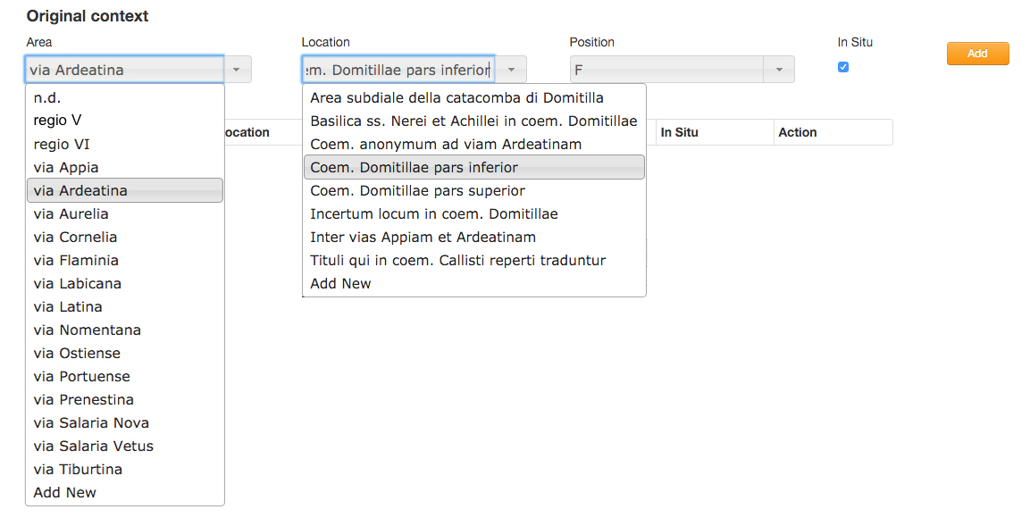

Fig. 4. Original context input fields.

Is worth noting that this set of associated fields refers to the original place of belonging of the inscriptions and not to the place where they have been found, unless the two data coincide, that is in the case of inscriptions *in situ* or *suo loco adplicitae*, accordance with the definitions of the ICVR*.*

To complete information on spatial data, all cemeterial contexts have been georeferenced, so that clicking on their name opens a new window in *Google Map* that shows the modern entrance to the cemetery, with the address and its coordinates (Fig. 5.a).

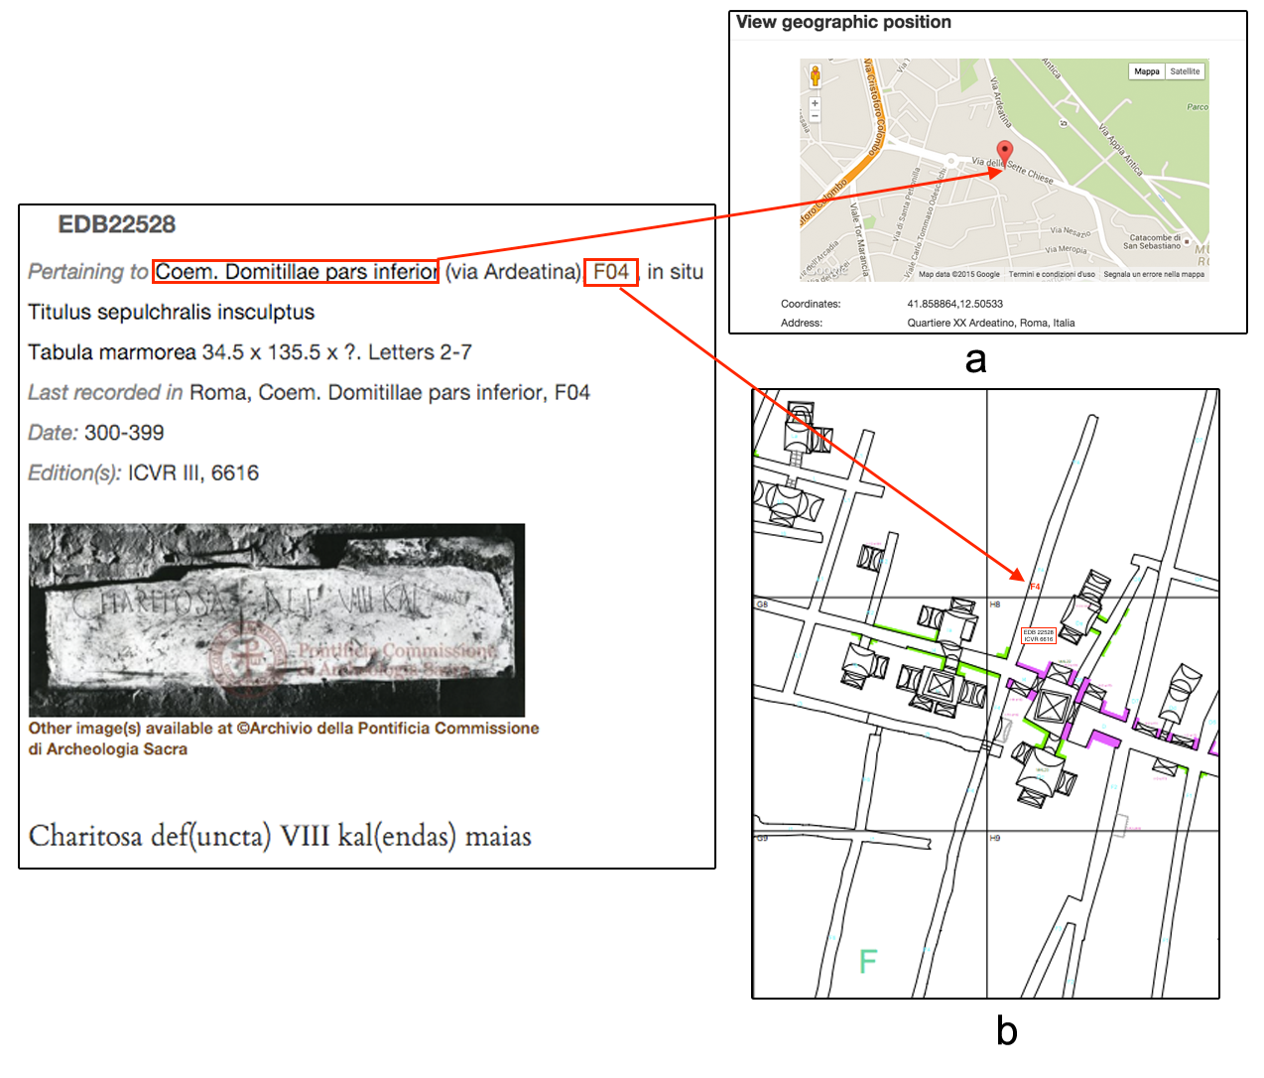

Fig.5. The *original context* maps.

As a case of study, for the inscriptions *in situ* pertaining to the Domitilla catacomb (Via Ardeatina) - the only cemetrial complex with a georeferenced plan of almost its entire extension[8] - clicking on the alphanumeric code[9] associated to the precise position of the inscriptions, gallery or cubiculum (F04, in Fig. 5., opens the plan of the specific area (*regio*) in which the inscription insists. In every plan, the inscriptions preserved *in situ* are placed and marked by ICVR and EDB number (Fig. 5b)[10].

Even the geographic data relating to the place of conservation of the inscriptions are managed with a similar structure. Since not a few inscriptions, produced in Rome, have been taken away and carried in other places in Italy or abroad, the information have been organized in three related fields reporting respectively the list of the cities, the list of associated structures, such as museums, churches, catacombs, and the specific positions in the context where the object is actually preserved.

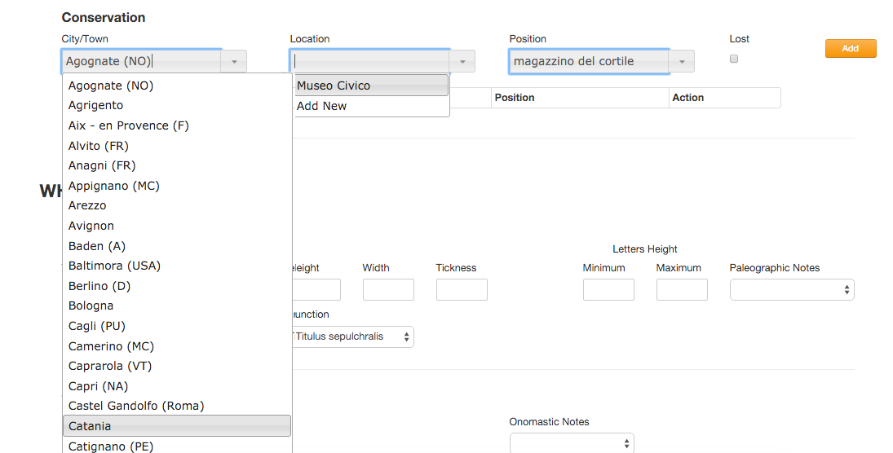

Fig. 6. Conservation input fields.

Adopting the best practice suggested by the EAGLE consortium, georeferencing is guaranteed even for the Conservation data, linking every City/Town to GeoNames site[11], which allows to pinpoint the location and to avoid ambiguity between homonyms. As well as a link to Trismegistos Collection[12], a database of papyrological and epigraphic collections, if available, helps to identify uniquely the place of conservation, as well as to obtain additional information, included the geographic positioning[13].

**2.3 The description of the epigraphic object**

The nature of the inscription as material objects carrying textual information is represented by a series of attributes, responding to the questions “What?” and “How?”: type of support and measures, executing technique, height of letters and paleographical features, cases of reuse.

A survey of terminologies intended for description of epigraphic objects in the ICVR volumes has been carried out and generated lists of controlled terms for some of the fields (Fig. 7). *Type of support, Executing technique* and *Function* vocabularies aimed at classifying the specific and peculiar materials, methods and functions of the inscriptions encoded in EDB, as the traditional epigraphic taxonomies do not totally adhere to their features.

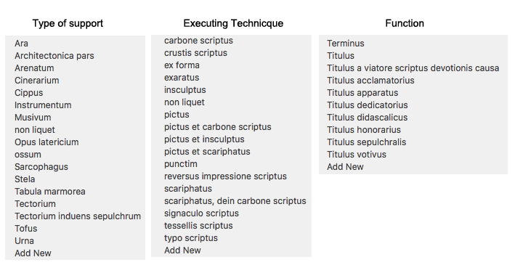

Fig. 7. Controlled vocabularies for *Type of support, Executing technique* and *Function* fields.

The controlled lists have been integrated in the vocabularies of the EAGLE community[14], that align, harmonize, create relations and translate into various languages the terms used by the various partners, and returns them in a format that allows to get a stable and unique identifier for each term, accessible and reusable by other users.

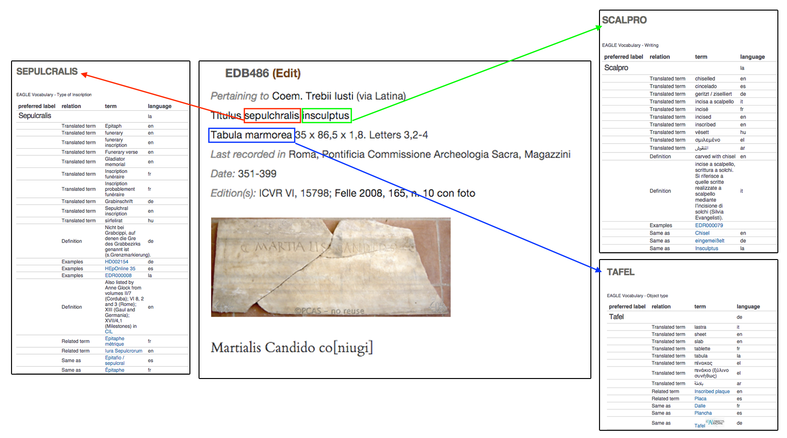

Fig. 8. The integration with EAGLE Vocabularies, that can be opened clicking on the highlighted terms,

**2.4 The text**

The nature of the inscription as a sequence of characters carried by a physical object is represented by a series of fields related to various features of texts: language and alphabet (Latin, Greek and the multiform combination of coexistence between them), metrical structure.

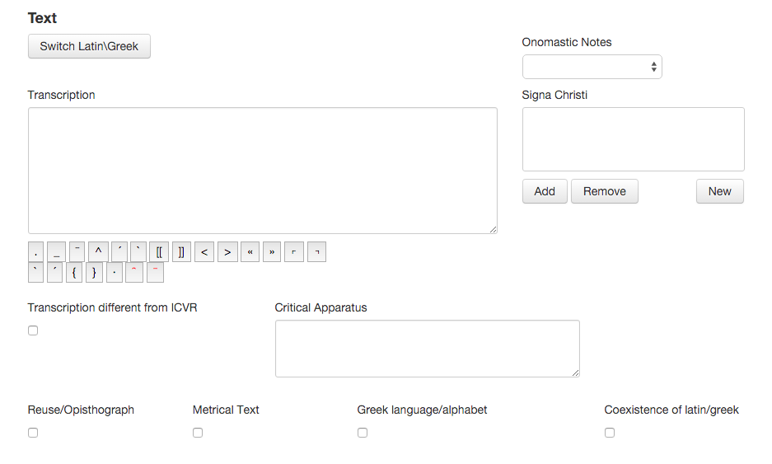

Fig. 9. Text fields in the submission mask.

The proper text of the inscription is stored in an apposite field, following the Krummrey - Panciera conventions[15], with some adjustments to make it capable to describe specific and peculiar issues of the inscriptions encoded in EDB. In particular the so-called "aberrant" forms are not "normalized" to the "standard" model, if they are recognized as grapho-phonetic outcomes of linguistic modifications of Latin and Greek.

While the fidelity to what is written on the stone (or other type of support) respects and takes in the due account the evolution of Greek and Latin language, it compromises the comprehension of the text and makes extremely complicate the text-based search of terms. A standard query system, in fact, is not able to match a query with all the inscriptions containing different spellings of a word. To face this issue each inscription is stored in its original form and in a “lemmatized” form, where each term is actually replaced with its corresponding lemma, possibly by taking into account its inflexed forms[16].

In EDB, as in every epigraphic database, the transcription of the text provides a real pre-edition, with systematic expansion of abbreviations, hypothesis of integration, and, if possible, also an update version of the text, according to recent publications. It includes, moreover, the description of non-alphabetic signs - in double round brackets - such as figurative elements (fishes, birds, anchors, etc.) and Christological monograms. Other fields record onomastic notes, *critical apparatus* and textual comment.

A series of fields, responding to the questions “When?” allows to insert a specific date, if recorded in the text, a specific time span (such as the duration of a Bishop of Rome or of an emperor), or a generic interval.

**2.5 The images**

Another meaningful improvement of EDB 2.0 is represented by the inclusion of visual representation of inscriptions. It’s evident how images dramatically increase analysis of epigraphic materials, showing them in their manifold aspects: reference with the context, form and quality of the support, graphic forms, technique peculiarities, layout and relationship between text and figurative or decorative elements[17].

In the frame of the collaborations with Europeana, the largest online collection of digitized items, EDB has been encouraged to enlarge the image repository, based on a cooperation agreements established between the EAGLE consortium and the Ministry of Culture (MIBACT) and the Pontifical Commission for Sacred Archaeology (PCAS). A new uploading process allowed tripling photos, squeezes, casts, published online in low resolution and with a visible digital watermark, respecting the restrictive Italian rules. A large part of the digital images stored in the EDB repository have been taken by collaborators during past years, part have been scanned from publications, while a large number come from the Photographic Archive of PCAS[18].

**3. Users, interface, search engine**

The system manage three kinds of users: editors, compilers and generic anonymous ones.

The last one can navigate in the descriptive section of the website (About EDB, People) and in the list of cited Publications. They have also access to the entire database using two research masks: a *Quick search* allows to choose searching only in one of the following fields: identifier EDB, bibliographic data and text; an *Advanced Search*, provides the opportunity to explore the database through multiple search criteria variously combined.

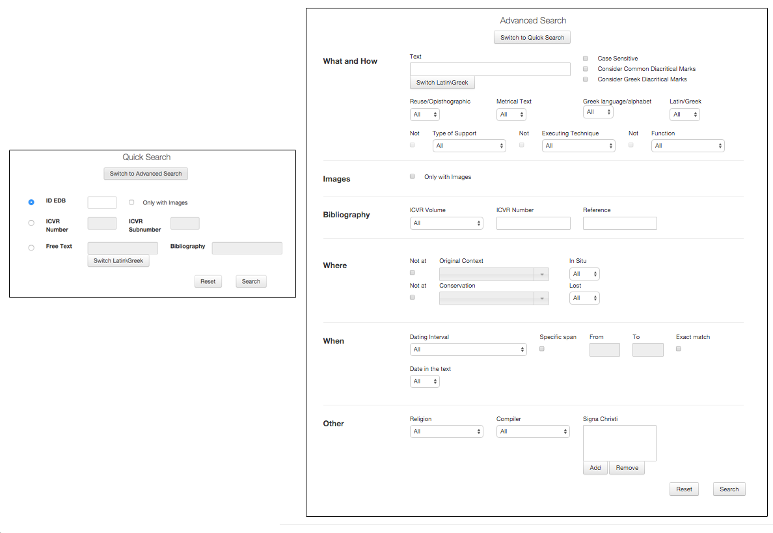

Fig. 10. Quick and Advanced Search masks.

Similarly to today's web search engines, EDB provides an advanced text search, in Latin and Greek - an integrated tool facilitates writing in Greek alphabet[19] - allowing users to obtain different results according to a default syntax, both in the case of search for a single word or for a set of terms, in sequence or not. Additionally, it's possible to choose whether or not to consider epigraphic diacritical marks, Greek accents and spirits and capitals. The textual search can be combined with other metadata related to bibliographic, geographic and material data, to the function, the reuse, the language and date, expressed in a single year or defined intervals.

This wide range of possibilities has been designed to reach users with different needs: the occasional one looking for a particular inscription could just type one or more words that he is able to read and decipher, and the specialist one, that can access detailed information about a single epigraph or use the advanced search to query the database about groups of documents with common characteristics.

The search results are listed in a table showing the EDB identifier, bibliographic data, place of original pertinence and place of conservation, text of the inscription and a link to the full record.

4. Conclusions

In this paper has been briefly described the growth of Epigraphic Database Bari in the last almost thirty years, from the first experimental and minimalistic version, intended just for the use of a small group of researchers of Bari University, to the present one, open to a large public of curious, students and, of courses, specialists.

The involvement in the EAGLE – Europeana project, network of Ancient Greek and Latin Epigraphy, has had a significantly positive impact on the development of the database of inscriptions by Christians from Rome.

In fact, although EDB, like other partner databases, maintained its character, dictated by its own story and, mostly, by the characteristics of its documentary base, it has taken advantage of the solutions adopted to integrate different archives and of the best practices purpose-built.

Among the improvements it’s worth mentioning

1. The inclusion of EDB structured bibliography in the Zotero Group, where it have been merged with the ones of other Content providers and have been made directly and publicly available in the most reusable way, gives more exposition of the bibliographic database; allows the integration and enrichment with other databases; consents easy export of data in multiple formats (bibtex, bookmarks, mods, rdf, xml, etc).

2. Following EAGLE best practice suggestions, data about modern places have been enriched with links to reference resources, as GeoNames and Trismegistos Collection[20], extending the use of stable and unique identifier accessible and reusable by other users (URI).

3. With the same aim, the controlled lists of *Type of support, Executing technique* and *Function* have been integrated in the corresponding vocabularies of the EAGLE community. Among other benefits, such as alignment and relations between databases, clicking on specific terms opens EAGLE vocabulary window with its translation into various languages. This feature is particularly useful in the case of EDB that, following ICVR, uses Latin for definitions, without modern language translations.

4. Encouraged by the collaborations with Europeana, EDB has tripled the amount of images stored in its repository, including inedited images taken by collaborators during the years.

On the other hand, EDB being inside Eagle since its beginning has been a bridgehead for the non standard epigraphies, proposing issues to the Eagle community, solved making more flexible the data model. It’s the case, for example, of adding more than an executive technique for a single support and more than one language and / or alphabet for the same inscription, indispensable to describe bilingual and/or bigraphic texts.

Other solutions adopted in EDB could be, in the future, suitable for other projects such as the hierarchic and multi-step organization of topographic data, that could be applied on closed contexts of every age (houses, columbaria, and so on) as well as the treatment of aberrant forms and the lemmatization process, that could be applied to every non standard language.

Bibliography

*Corpora*

CIL = *Corpus Inscriptionum Latinarum*, Berolini 1863 ss.

CIG = *Corpus Inscriptionum Grecarum,* I-IV, Berolini 1828-1877

IC = *Inscriptiones christiane urbis Romae septimo saeculo antiquiores*, I-II, G.B. de Rossi (a c.), Romae 1857-1861; *Supplementum*, G. Gatti (a c.), Romae 1915.

IG = *Inscriptiones Graecae,* Berolini 1873 ss.

ICVR= *Inscriptiones christianae urbis Romae septimo saeculo antiquiores. Nova series,* I-X, A. Silvagni, A. Ferrua, D. Mazzoleni, C. Carletti (a c.),Romae - In Civitate Vaticana 1922 ss.

IGVR = *Inscriptiones grecae urbis Romae,* I-IV, L. Moretti (a c.), Roma 1968-1990.

Carletti 1994 = C. Carletti, *Inscriptiones christianae urbis Romae, nova series. Una banca dati*, in «VeteraChr» 31, 1994, pp. 357-368.

Carletti 1997 = C. Carletti, *Introduzione,* in Felle 1997, pp. vii-xxxiv.

Ceci, Pio, Rocco 2014 = M. Ceci, G. Pio, A. Rocco, *Improving text-based search of inscriptions*, in Eagle 2014, pp. 21-30.

Eagle 2014 = *Information Technologies for Epigraphy and Cultural Heritage*. Proceedings of the First EAGLE International Conference (Paris, September 29-30 - October, 1, 2014), Roma 2014

Felle 1997 = A. E. Felle (a c.), *Inscriptiones christianae urbis Romae, tituli graeci. Concordantiae uerborum, nominum et imaginum*, Bari 1997.

Felle 2007 **=** A.E. Felle, *Fenomeni di compresenza delle lingue e delle scritture greca e latina nella epigrafia romana di committenza cristiana*, in M. Mayer i Olivé, G. Baratta, Al. Guzmán Almagro (a c.), Acta XII Congressus Internationalis Epigraphiae Graecae et Latinae. Provinciae Imperii Romani inscriptionibus descriptae (Barcelona, 3-8 septembris 2002), Barcelona 2007, pp. 475-481.

Felle 2012 = A.E. Felle, *Esperienze diverse e complementari nel trattamento digitale delle fonti epigrafiche: il caso di EAGLE ed EpiDoc*, in *Diritto romano e scienze antichistiche nell’era digitale*. Convegno di studio (Firenze, 12-13 settembre 2011), Torino 2012, pp. 117-130.

Felle 2014 = A.E. Felle, *Perspectives on the digital corpus of the Christian inscriptions of Rome (Epigraphic Database Bari). Contexts and texts*, in «ZPE» 191, 2014, pp. 302-307.

Felle, Zimmermann 2014 = A.E. Felle, N. Zimmermann, *A Case of Interaction between Research Projects: The Epigraphic Database Bari and the Domitilla Projekt*, in Eagle 2014, pp. 75-96.

Jory 1975 = E.J. Jory, *Problems and Prospects for the Production of Computer Compiled* indices *to Epigraphic Works*, in «AntAfr» 9, 1975, pp. 15–22.

Jory, Moore 1974-75 = E.J. Jory, D.W. Moore (eds.), *Corpus Inscriptionum Latinarum,* vol. VI, pars vii, *Indices Vocabulorum,* I-VI, Berolini 1974-1975.

Krummrey, Panciera 1980 = H. Krummrey, S. Panciera, *Criteri di edizione e segni diacritici,* in *Tituli* 2, Roma 1980, pp. 205-215.

Panciera 2006 = S. Panciera, *EAGLE: Cronistoria di un problema e di un progetto*, in Id., *Epigrafi, epigrafia, epigrafisti. Scritti vari editi e inediti (1956-2005) con note complementari e indici,* I-III (Vetera, 16), Roma 2006, pp. 1913-1917.

Panciera 1991 = S. Panciera, *Struttura dei Supplementi e segni diacritici dieci anni dopo,* in *Supplementa Italica* n.s. 8, Roma 1991, pp. 9-21.

Panciera et alii 2006 = S. Panciera, W. Eck, D. Manacorda, C. Tedeschi, *Questioni di metodo. Il monumento iscritto come punto d’incontro tra epigrafia, archeologia, paleografia e storia (a proposito dei primi tre volumi di Supplementa Italica – Imagines*), in «Scienze dell’Antichità» 13, 2006, pp. 583-660.

The author would like to acknowledge the support of the European Commission through the project EAGLE - Europeana network of Ancient Greek and Latin Epigraphy (Grant no: 325122). Moreover, the author thanks Carlo Carletti, Antonio E. Felle, Filippo A. Piazzolla, Marida Pierno, Gianvito Pio who daily use EDB and manage the input of inscriptions and metadata and the entire EAGLE community, a space of real networking, debating and sharing ideas and data.

Acknowledgement

1. He was professor of *Epigrafia e antichità cristiane* in the former *Department of Classical and Christian Studies* of Bari University.
2. Jory - Moore 1974-75. The six volumes of the computerized KeyWord-In-Context index to all the approximately 40,000 texts collected in the VI volume of the *Corpus Inscriptionum Latinarum* (CIL) are the outcome of a trailblazing work of arrangement and organization of the inscriptions in a *database*, even if limited to their textual part.
3. The *Corpus* of *Inscriptiones christianae urbis Romae* started in 1922 by A. Silvagni, was published, mostly, by A. Ferrua, later supported by D. Mazzoleni and C. Carletti, between 1956-1992. Pursuing the work of G.B. de Rossi of the mid-1800s (IC), ICVR registers the inscriptions by Christians found in the suburban area of Rome, sorted in topographic order by consular road, then by catacomb. Inscriptions found inside the urban walls, as well as the suburban ones recently discovered aren’t so far included in the ICVR volumes.
4. The program didn’t allow the use of Greek fonts, adding texts in Greek alphabet it was necessary to type Latin equivalent letters in the MS Word *Symbol* font, as you can see in Fig. 1.
5. Carletti 1994, Id. 1997a, pp. viii-ix.
6. The archetype of this signs can be considered the monogram consisting of the first two letters of the name Χριστός. They appear in inscription at the beginning of the IVth century.
7. www.zotero.org/groups/eagleepigraphicbibliography/items
8. *START-Projekt: Die Domitilla-Katakombe in Rome (Institut für Kulturgeschichte der Antike - Österreichische Akademie der Wissenschaften).* Felle, Zimmermann 2014.
9. The code are made by a majuscule letter, relating to a region of the catacomb and by another element, digit or minuscule letter, relating to a precise internal position, respectively a gallery or a *cubiculum.*
10. The plans are available on START-Projektwebsite: [www.oeaw.ac.at/antike/index.php&id=431](http://www.oeaw.ac.at/antike/index.php&id=431), clicking on EDB number opens a window with the EDB record.
11. www.geonames.org
12. www.trismegistos.org
13. http://www.eagle-network.eu/wp-content/uploads/2013/06/EAGLE_D2.2.2_Content-harmonisation-guidelines-including-GIS-and-terminologies-Second-Release.pdf
14. <http://www.eagle-network.eu/resources/vocabularies/>.
15. Krummrey, Panciera 1980; Panciera 1991.
16. On the contrary, if the compiler recognizes aberrant forms as outcomes of misstatements and material mistakes of the stonecutters, he transcribes them with the appropriate corrections, following the Krummrey - Panciera conventions. Felle 2014 e Ceci, Pio, Rocco 2014.
17. Panciera et al. 2006.
18. www.archeologiasacra.net
19. *Greek Inputter 2*, developed by J. Naughton it allows to write in greek using their usual keyboard and to digit with simple steps, various greek diacritical marks (http://babel.mml.ox.ac.uk/ naughton / polytonic-greek-inputter.html).
20. http://www.eagle-network.eu/wp-content/uploads/2013/06/EAGLE_D2.2.2_Content-harmonisation-guidelines-including-GIS-and-terminologies-Second-Release.pdf